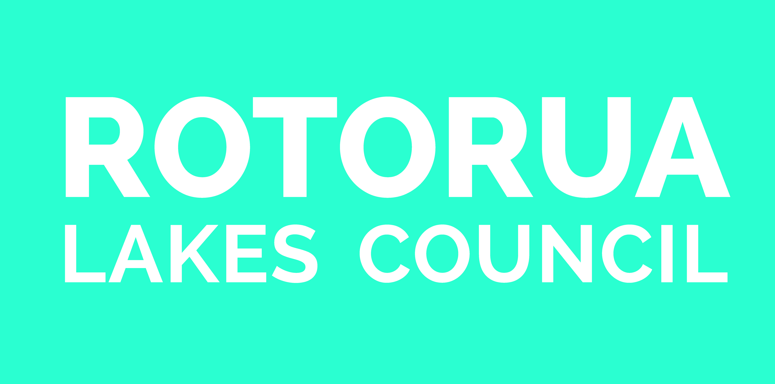
Mayoral Manaakitanga Relief Fund
TERMS OF REFERENCE

What is the purpose of the fund?

The Rotorua Mayoral Manaakitanga Relief Fund has been established by the Rotorua Lakes Council to provide disaster relief assistance to those Rotorua residents most affected by the flooding in April 2018.

The Council will appoint four assessment committee members to administer the fund. They are: The Mayor, Councillor, Te Tatau and Rural Board representatives.

The fund will provide a one-off hardship grant to affected residents, with priority given to:

- Extra financial burden or costs due to the flooding
- Family or personal crisis
- Costs not covered by insurance or other funds, such as WINZ support

It is intended that these grants will go some way towards helping alleviate the emotional and financial stress experienced by those impacted by the flooding event.

Who can apply?

The fund is open to Rotorua residents who have been directly impacted by the April 2018 flooding event, and require financial support. Only one application will be considered per household.

In order to be eligible for the grant:

- Applicants apply they must be experiencing hardship as a result of the April 2018 flooding event;
- Applicants must be registered as having been affected by the flood with the Rotorua Lakes Council;
- Priority will be given to those households that were usually residing at the affected address (owner/occupier or occupier (tenant) ) in the Rotorua District on the 29th April 2018;
- Applicants should not apply for this fund if costs have already been covered by insurance or other sources BUT they may still be eligible if that funding assistance has not substantially reduced the financial loss or hardship suffered;
- If applicable, applicants must disclose insurance information;
- The assessment committee reserves the right to approve or decline grants and will not exceed funds available.

How do people get a grant from the fund?

The fund will be open for applications for grants from (TBC: still awaiting Council sign off)

In order to apply for a grant, applicants must complete the application form. This form is available from the Council Offices and on the Council’s website,
http://www.rotorualakescouncil.nz/our-services/CDrecoveryproject/Pages/default.aspx`

Applicants must complete the application form while demonstrating that their circumstances are due to the flooding event. Assistance will be provided with filling in the form if required. Ph: 348 4199 to speak with a Council support person.

Applications can be submitted by hand delivery, post or email:

Rotorua Lakes Council Offices
1061 Haupapa Street
Rotorua

Post:
Rotorua Mail Centre
Private Bag 3029
Rotorua 3046

Email:
info@rotorualc.nz

Who decides who gets the money and how do they decide?

The committee will assess applications according to the purpose of the fund, criteria specified above and funds available. Applicants will be notified of the decision within three weeks of submitting their application.

How is the money to be paid to people?

Grants will be paid directly into a bank account in the name of the applicant (or into a joint account where the name of the applicant is one of the joint names on the account). Payments will only be made into bank accounts in the name of individuals, not into those of businesses or other organisations.

What will happen to any money left over?

In the event that there is money left over, the Council will work with the Geyser Community Foundation to redistribute the funds to benefit the Rotorua community.

How will administration of the fund be reported?

Regular reports will be made to the Council on the balance of the fund, allocation of grants and any other administration matters. The agenda and minutes of these meetings are publicly available from Council Offices and on the Council website, www.rotorualakescouncil.nz. No details of individual grant amounts or who the grants are made to will be made public.

